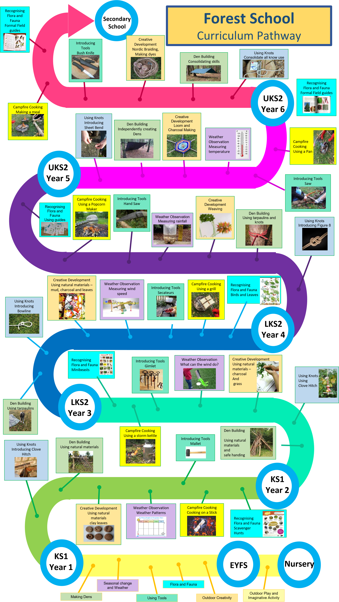
FOREST SCHOOL
CURRICULUM PATHWAY

